The History of Ironman  How Ironman Started | Abstract  Ironman is a Font of Excellence. Inspiration, Dream, Accomplishment!  Rose Mari Goncalves  CSIS 1020

The History of Ironman
Introduction:
I am Talking today about the History of Ironman. Who is the Fittest Athlete?
Tom Brady (The Best American Football Player New England Patriots, Lelisa Desisa (Won the Boston Marathon in 2 hours and 8 minutes) or Cristiano Ronaldo (Best soccer player of the World)

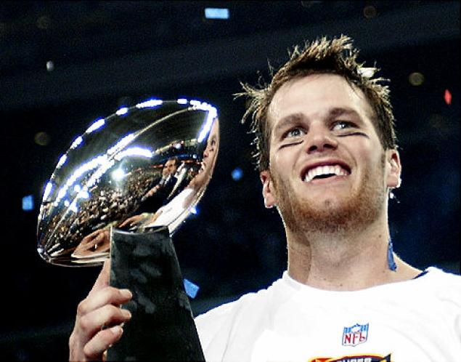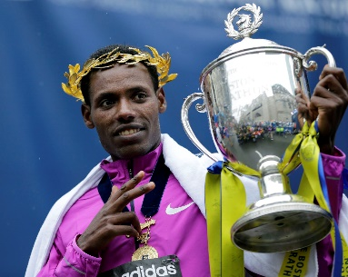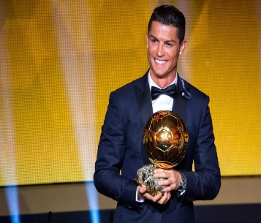
Body:
Back in 1978 in Oahu Hawaii John Collins a retired Captain of the U.S. Navy was at a reception. Among the participants were representatives of both the Mid-Pacific Road Runners and the Waikiki Swim Club, whose members had long been debating which athletes were more fit, runners or swimmers one of them run marathons?
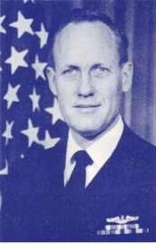
Who is the fittest?
John Collins had declared that Eddy Merckx, the great Belgian cyclist, had the highest recorded "oxygen uptake" of any athlete ever measured, so perhaps cyclists were more fit than anyone.
Collins said well we need to make a test let’s see who is the fittest athlete how can we do it? If they all do a swim the swim guy is going to win right? If they all do a run, is not fare because the runner guy is going to win. What they decide to do?
Collins came up with a great idea. Do all three at once. so they understood the concept when Collins suggested that the debate should be settled through a race combining the three existing long-distance competitions already on the island: the Waikiki Rough water Swim (2.4 mi./3.86 km), the Around-Oahu Bike Race (115 mi./185.07 km; originally a two-day event) and the Honolulu Marathon (26.219 mi./42.195 km).
Collins then issued the challenge and said that whoever gets to the finish line first will be called the Ironman.

John Collins, the creator of this crazy grueling race, would finish in a little under 17 hours.
Of the fifteen men to start off in the early morning on February 18, 1978, twelve completed the race. Gordon Haller, a US Navy Communications Specialist, was the first to earn the title Ironman in history by completing the course with a time of 11 hours, 46 minutes, 58 seconds.
The runner-up John Dunbar, a US Navy SEAL, led after the second transition and had a chance to win but ran out of water on the marathon course; his support crew resorted to giving him beer instead.
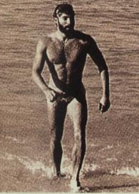
Gordon Haller
Conclusion:
.

In Conclusion Athletes all over the world wants to have the strength and endurance to qualify or be invited to participate to Kona Hawaii World Championship Ironman. Like John Collins and Gordon Haller did.
.
"Swim 2.4 miles! Bike 112 miles! Run 26.2 miles! Brag for the rest of your life", now a registered trademark.
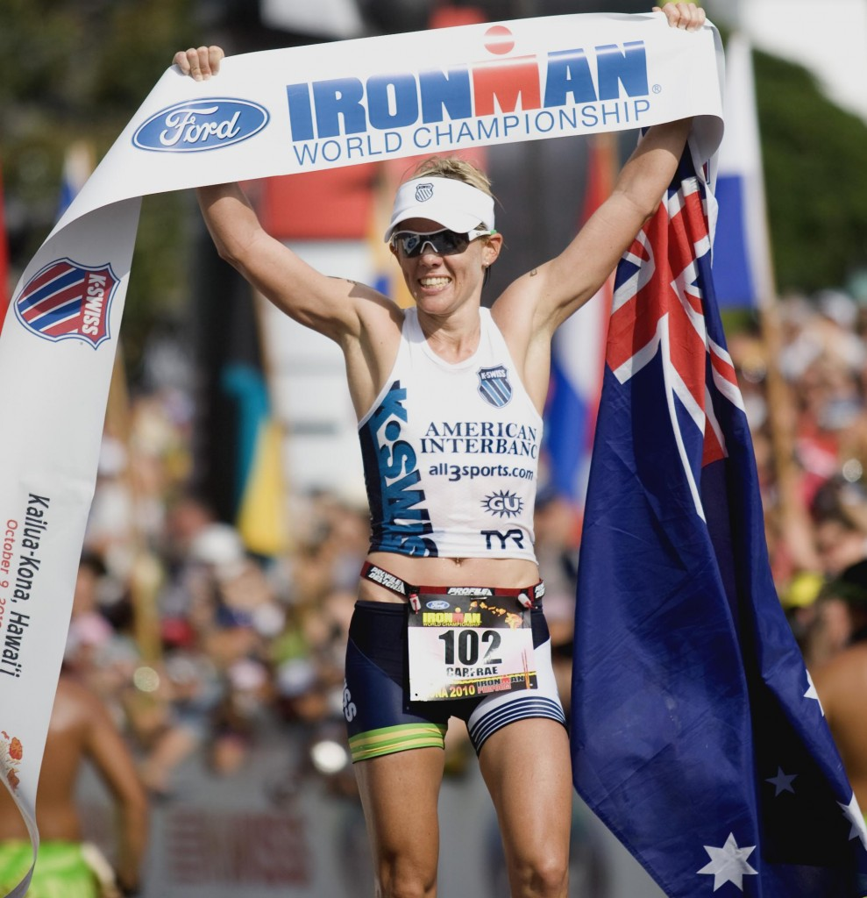
My Inspiration is Mirinda Carfrae

